**LOW_LEVEL DESIGN**

**HOMEPAGE**

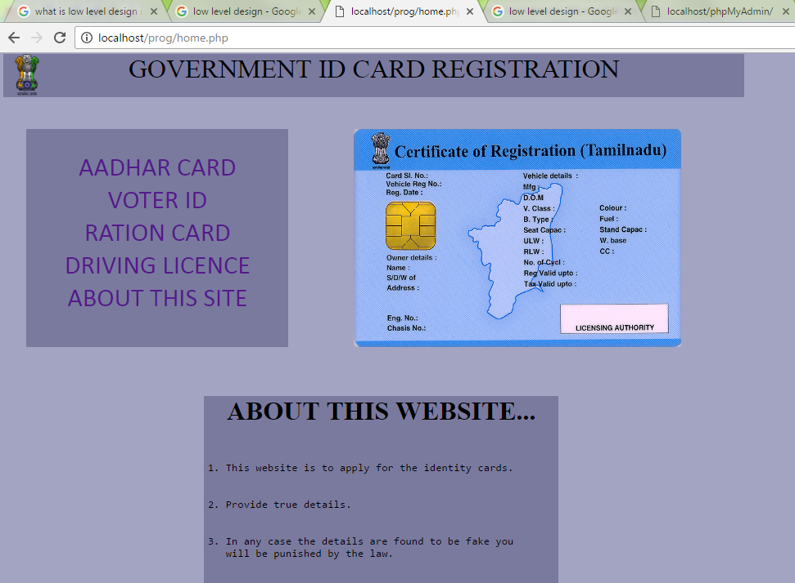

on the top left corner government symbol is placed that has to be seen this website belongs to government.

Php code used for design.

Text size used 16’’inches

On the header part, given colour is dark blue. Text colour is black

four government id card registration links. The colour is given violet to show unique. user can click register new id card or track the registered card.

He can see about this website.Four id card photo pictures changing alternatively are visible on right side of this page.

**REGISTRATION AND UPLOADING PROOF COPIES** 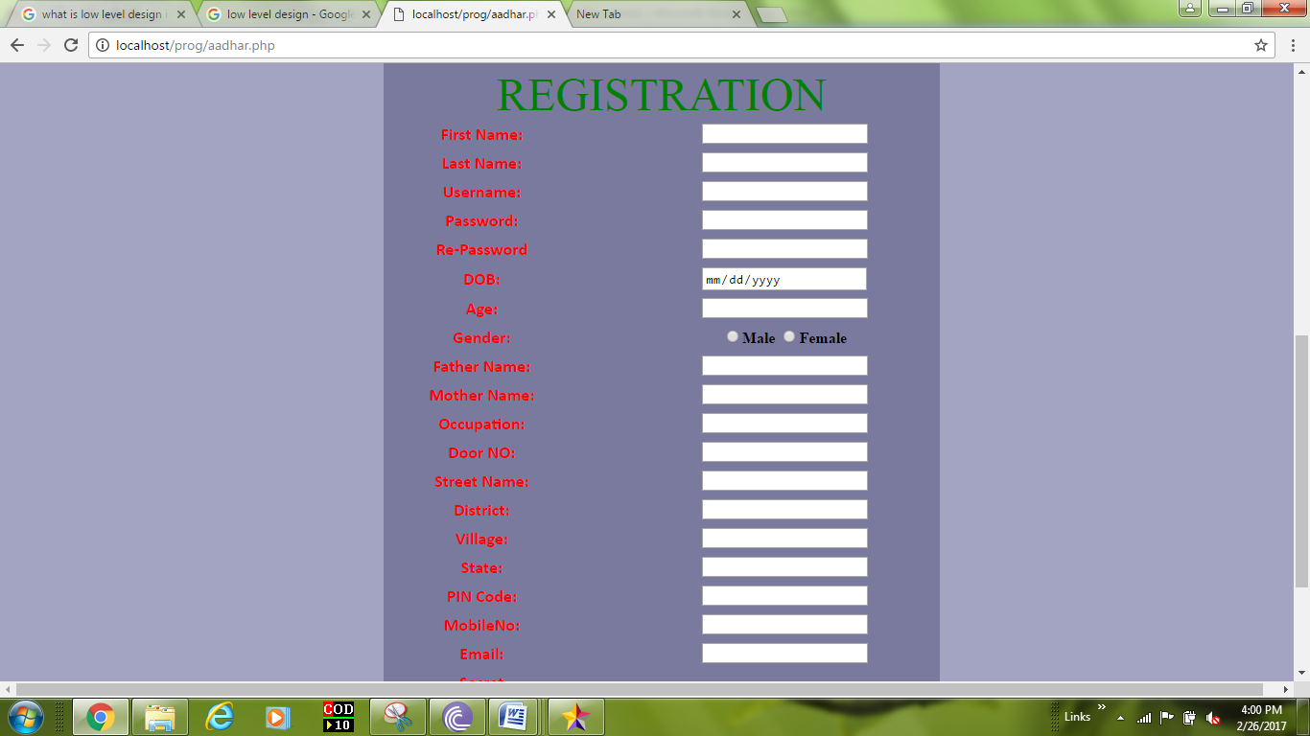

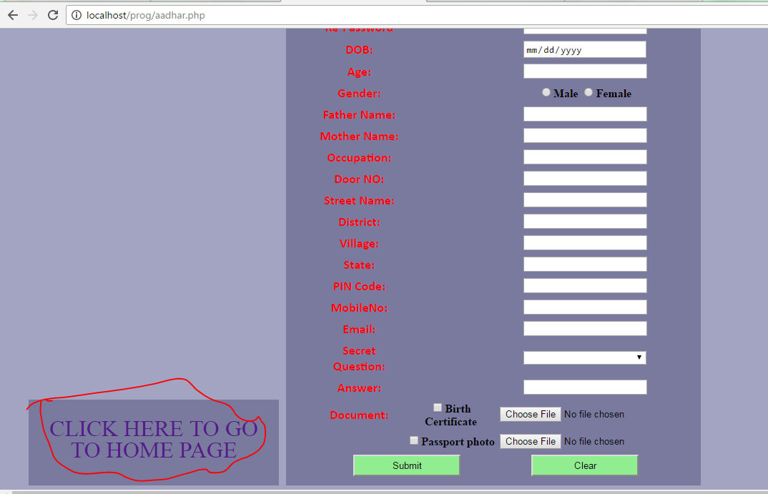

The form is table of contents is made center using html and css.

Highlighted the table wit background color.

Text box size width 10. background Colour used dark blue .

Text colour on first column of table is red and second col is text boxes.

Drop down box is used to choose options is 1. Radio buttons used side by side.

Check boxes is used. ‘’Action button’’ is used. Given colour is green.

“click here to go to homepage “on left side of registration form. Colour given dark blue. Text colour and size is violet , 18’inches.

Choose file button used is action and after chose file name will display next to button.

**LOGIN FORM**

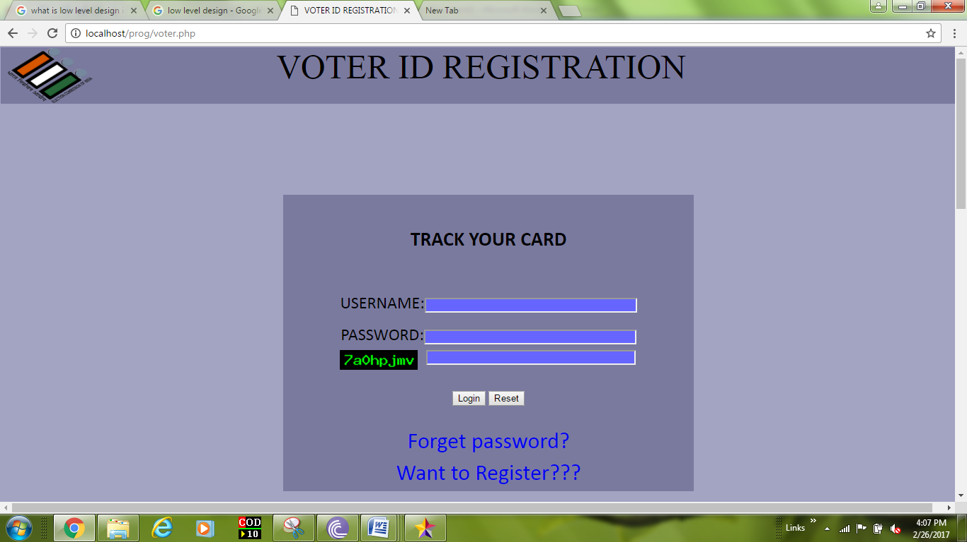

Username textbox style="font-family:Calibri;font-size:28. It has id that access to user registered username in registered form .

Password input type is in password.

Captcha is used input style=position:absolute; left:262px;"type="text".

Captcha is based on session using php coding.

Submit button use type- submit.

Reset button use type-reset.

Down Two links are used color –blue font-calibri.

**FORGOT PASSWORD**

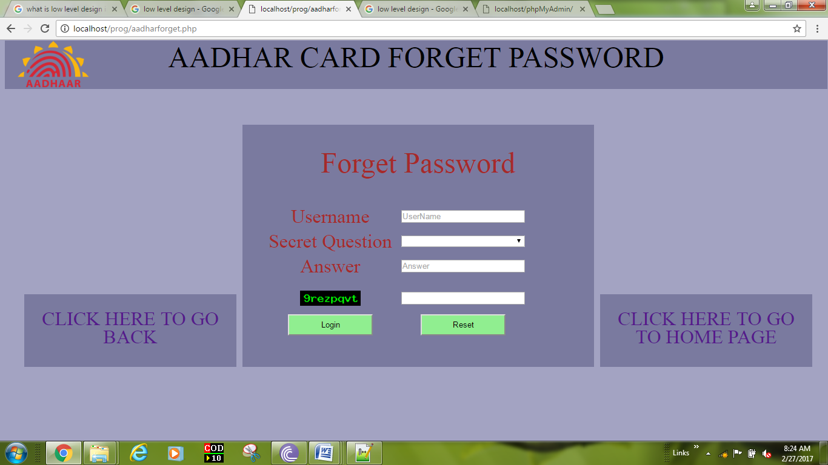

forgotten password login form background color is dark blue. Text color is

Username input type is textbox.

Dropdown box is used. Uses “palce holder type” to select.

Captcha is used using session php code in input style="position:absolute; left:262px;"type="text"

**Pagelinks** are used to shift back page or homepage on both corner sides of the page.

Aadhar card symbol is placed on top-left corner.

**DATABASE SYSTEM:**

mysql databases created and access using php code.The registered user details have secured with password . operations such as creating, updating ,retrieving and deleting information details on databases. Mysqli_connect is new at present databases system.

This registration website designed using php, html, CSS . And also worked on java platform. Admin can be operating the system databases. He will made updating the changes. Uses javascript.

For the tracking , accessing databases to display output/result.

It will be used as table format. It can filtered, or arranged by sorting.

Servers are fastable and more compatible to work .

